**XML setup on ATM**

When copying vita/installing or struggling with vista starting on ATM, it is always a good idea to check XML setup.

Vista uses 5 files for configuration that are unique for on every ATM:

REMOTESERVERCONFIG

VSSCLIENTCONFIG

VSSCLIENTHARDWARECONFIG

VSSCLIENTIDENTITY

VSSCLIENTLOYALTY

Those files can be accessed without logging to ATM by accessing this path using internet explorer on jumpbox:

\\ucXXXatmYY\c$\VISTA\VistaKiosk\Config

Where XXX is site id and YY is ATM number.

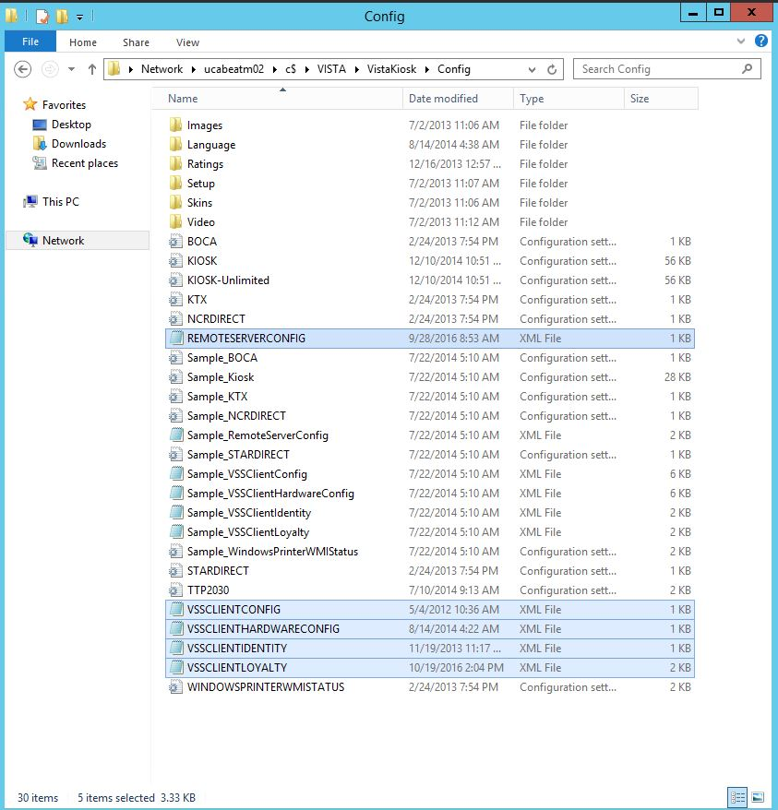

**REMOTESERVERCONFIG**

Serverid and url should be either site viscin1 name or IP address

-10.202.XX.2 is viscin1 ip. XX is unique number for site. For example Aberdeen will have either:

Ip 10.202.50.2 or ucabep-viscin1

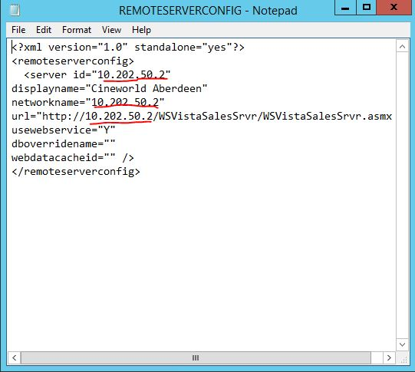

**VSSCLIENTCONFIG**

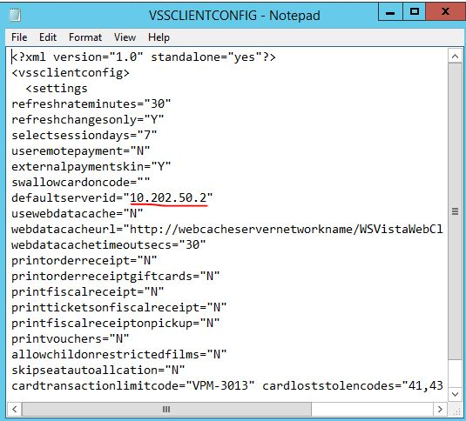

Same as with REMOTESERVERCONFIG this should be either name of viscin1 or ip of viscin1 for particular site.

**VSSCLIENTHARDWARECONFIG**

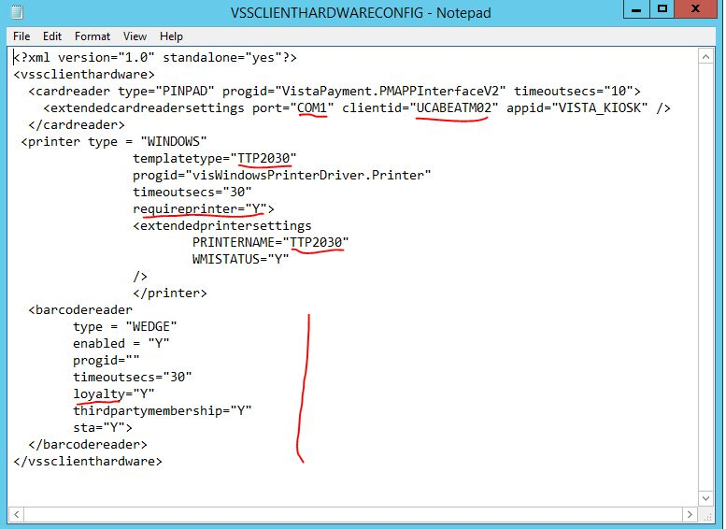**port**=”com1”

This should be the same for most sites

**Client id**

should always be:

UCXXXATMYY where

XXX- site code

YY- ATM number

**Template type** and **Printername**

This depends on printer connected to ATM. In most cases this will either be “STAR” or “TTP2030”

**Requireprinter**: this varies from site to site. If this is “Y” Vista will crash on start when printer will fail initializing

**Barcodereader:** on sites where ATM’s use loyalty, loyalty should be “Y”. if this is set to “N” or there is no string for this ATM’s won’t be able to use loyalty cards/

**VSSCLIENTIDENTITY**

Client id should be in most cases 111.111.222.22Y

Where “Y” is number of the ATM

For example for ATM01 this should be 111.111.222.221

Important part regarding this is that two ATM’s should NOT have the same client id as this may cause issues.

“Workstation id” and “payment client id” should always be UCXXXATMYY

Where XXX is site id and YY is the number of ATM



**VSSCLIENTLOYALTY**



LMC_strCinemaID

-This is digit that is unique for a site. You can find those for all sites in excel file “List of sites” or in the site SQL under tbl.LoyaltyModuleConfig under string LMC_strCinemaID

ServiceURL

This should always be: http://10.130.6.10/visLoyalty/VistaLoyalty.asmx